**You are troubleshooting a performance issue for an Azure Application Gateway.**

**You need to compare the total requests to the failed requests during the past six hours.**

**What should you use?**

### Ans - Metrics in Application Gateway

#### Azure Application Gateway is a web traffic load balancer that enables you to manage traffic to your web applications. Traditional load balancers operate at the transport layer (OSI layer 4 - TCP and UDP) and route traffic based on source IP address and port, to a destination IP address and port.

#### With Application Gateway, you can make routing decisions based on additional attributes of an HTTP request, such as URI path or host headers. For example, you can route traffic based on the incoming URL. So if /images is in the incoming URL, you can route traffic to a specific set of servers (known as a pool) configured for images. If /video is in the URL, that traffic is routed to another pool that's optimized for videos.

#### This type of routing is known as application layer (OSI layer 7) load balancing. Azure Application Gateway can do URL-based routing and more.

#### By using Azure Application Gateway, you can monitor resources in the following ways:

#### Back-end health: Application Gateway provides the capability to monitor the health of the servers in the back-end pools through the Azure portal and through PowerShell. You can also find the health of the back-end pools through the performance diagnostic logs.

#### Logs: Logs allow for performance, access, and other data to be saved or consumed from a resource for monitoring purposes.

#### Metrics: Application Gateway has several metrics which help you verify that your system is performing as expected.

<https://docs.microsoft.com/en-us/azure/application-gateway/application-gateway-diagnostics#metrics>

**You have two subscriptions named Subscription1 and Subscription2. Each subscription is associated to a different Azure AD tenant.**

**Subscription1 contains a virtual network named VNet1. VNet1 contains an Azure virtual machine named VM1 and has an IP address space of 10.0.0.0/16.**

**Subscription2 contains a virtual network named VNet2. VNet2 contains an Azure virtual machine named VM2 and has an IP address space of 10.10.0.0/24.**

**You need to connect VNet1 to VNet2.**

**What should you do first?**

### Ans - Provision virtual network gateways.

#### The virtual networks can be in the same or different regions, and from the same or different subscriptions. When connecting VNets from different subscriptions, the subscriptions do not need to be associated with the same Active Directory tenant.

#### Configuring a VNet-to-VNet connection is a good way to easily connect VNets. Connecting a virtual network to another virtual network using the VNet-to-VNet connection type (VNet2VNet) is similar to creating a Site-to-Site IPsec connection to an on-premises location. Both connectivity types use a VPN gateway to provide a secure tunnel using IPsec/IKE, and both function the same way when communicating.

#### The local network gateway for each VNet treats the other VNet as a local site. This lets you specify additional address space for the local network gateway in order to route traffic.

**You have an Azure subscription that contains the resources in the following table.**

**\*\*\***

**Name: VNet1,··················Type: virtual network·········Azure region: West US·········Resource group: RG2**

**Name: VNet2,··················Type: virtual network·········Azure region: West US·········Resource group: RG1**

**Name: VNet3,··················Type: virtual network·········Azure region: East US·········Resource group: RG1**

**Name: NSG1,···················Type: Network security group (NSG)Azure region: East US·········Resource group: RG2**

**\*\*\***

**To which subnets can you apply NSG1?**

### Ans - The subnets on VNet3 only.

<https://docs.microsoft.com/en-us/azure/virtual-network/virtual-network-vnet-plan-design-arm>

**You have five Azure virtual machines that run Windows Server 2016. The virtual machines are configured as web servers.**

**You have an Azure load balancer named LB1 that provides load balancing services for the virtual machines.**

**You need to ensure that visitors are serviced by the same web server for each request.**

**What should you configure?**

### Ans - Session persistence to Client IP

<https://cloudopszone.com/configure-azure-load-balancer-for-sticky-sessions/>

**You have the Azure virtual networks shown in the following table.**

**\*\*\***

**Name: VNet1,··················Address space: 10.11.0.0/16,··Subnet: 10.11.0.0/17,·········Azure Region: West US**

**Name: VNet2,··················Address space: 10.11.0.0/17,··Subnet: 10.11.0.0/25,·········Azure Region: West US**

**Name: VNet3,··················Address space: 10.10.0.0/22,··Subnet: 10.10.1.0/24,·········Azure Region: East US**

**Name: VNet4,··················Address space: 192.168.16.0/22,Subnet: 192.168.16.0/24,······Azure Region: North Europe**

**\*\*\***

**To which virtual networks can you establish a peering connection from VNet1?**

### Ans - VNet2, VNet3, and VNet4

#### You can connect virtual networks to each other with virtual network peering. These virtual networks can be in the same region or different regions (also known as Global VNet peering). Once virtual networks are peered, resources in both virtual networks are able to communicate with each other, with the same latency and bandwidth as if the resources were in the same virtual network.

**You have an Azure subscription that contains a policy-based virtual network gateway named GW1 and a virtual network named VNet1.**

**You need to ensure that you can configure a point-to-site connection from VNet1 to an on-premises computer.**

**Which two actions should you perform? Each correct answer presents part of the solution.**

**NOTE: Each correct selection is worth one point.**

### Ans - Create a route-based virtual network gateway.

### Delete GW1

<https://docs.microsoft.com/en-us/azure/vpn-gateway/vpn-gateway-connect-multiple-policybased-rm-ps>

<https://docs.microsoft.com/en-us/azure/vpn-gateway/create-routebased-vpn-gateway-portal>

**You have an Azure subscription named Subscription1 that contains the resource groups shown in the following table.**

**\*\*\***

**Name: RG1,····················Region: East Asia**

**Name: RG2,····················Region: East US**

**\*\*\***

**In RG1, you create a virtual machine named VM1 in the East Asia location.**

**You plan to create a virtual network named VNET1.**

**You need to create VNET1, and then connect VM1 to VNET1.**

**What are two possible ways to achieve this goal? Each correct answer presents a complete solution.**

**NOTE: Each correct selection is worth one point.**

### Ans - Create VNET1 in RG2, and then set East Asia as the location

### Create VNET1 in RG1, and then set East Asia as the location.

<https://docs.microsoft.com/en-us/azure/azure-resource-manager/management/overview>

**You have an Azure subscription that contains a virtual network named VNet1. VNet1 contains four subnets named Gateway, Perimeter, NVA, and Production.**

**The NVA subnet contains two network virtual appliances (NVAs) that will perform network traffic inspection between the Perimeter subnet and the Production subnet.**

**You need to implement an Azure load balancer for the NVAs. The solution must meet the following requirements:.**

**\* The NVAs must run in an active-active configuration that uses automatic failover.**

**\* The NVAs must load balance traffic to two services on the Production subnet. The services have different IP addresses.**

**Which three actions should you perform? Each correct answer presents part of the solution.**

**NOTE: Each correct selection is worth one point.**

Ans –

### Add a frontend IP configuration, two backend pools, and a health probe.

### Add two load balancing rules that have HA Ports and Floating IP enabled

### Deploy a standard load balancer.

<https://docs.microsoft.com/en-us/azure/load-balancer/load-balancer-overview>

<https://docs.microsoft.com/en-us/azure/load-balancer/load-balancer-multivip-overview>

**You manage a virtual network named VNet1 that is hosted in the West US Azure region.**

**VNet1 hosts two virtual machines named VM1 and VM2 that run Windows Server.**

**You need to inspect all the network traffic from VM1 to VM2 for a period of three hours.**

**Solution: From Azure Network Watcher, you create a packet capture.**

**Does this meet the goal?**

Ans – No

Use connection monitor feature of Azure network watcher

<https://docs.microsoft.com/en-us/azure/network-watcher/connection-monitor>

**You have an Azure subscription named Subscription1 that contains two Azure virtual networks named VNet1 and VNet2. VNet1 contains a VPN gateway named VPNGW1 that uses static routing. There is a site-to-site VPN connection between your on-premises network and VNet1.**

**On a computer named Client1 that runs Windows 10, you configure a point-to-site VPN connection to VNet1.**

**You configure virtual network peering between VNet1 and VNet2. You verify that you can connect to VNet2 from the on-premises network. Client1 is unable to connect to VNet2.**

**You need to ensure that you can connect Client1 to VNet2.**

**What should you do?**

### Ans - Download and re-install the VPN client configuration package on Client1.

#### P2S VPN routing behavior is dependent on the client OS, the protocol used for the VPN connection, and how the virtual networks (VNets) are connected to each other.

#### Azure currently supports two protocols for remote access, IKEv2 and SSTP. IKEv2 is supported on many client operating systems including Windows, Linux, MacOS, Android, and iOS. SSTP is only supported on Windows. If you make a change to the topology of your network and have Windows VPN clients, the VPN client package for Windows clients must be downloaded and installed again in order for the changes to be applied to the client.

<https://docs.microsoft.com/en-us/azure/vpn-gateway/vpn-gateway-about-point-to-site-routing>

**You have an Azure subscription that contains the resources in the following table.**

**\*\*\***

**Name: VNet1,··················Type: Virtual network,········Details: Not applicable**

**Name: Subnet1,················Type: Subnet,·················Details: Hosted on VNet1**

**Name: VM1,····················Type: Virtual machine,········Details: On Subnet1**

**Name: VM2,····················Type: Virtual machine,········Details: On Subnet1**

**\*\*\***

**VM1 and VM2 are deployed from the same template and host line-of-business applications accessed by using Remote Desktop.**

**You need to prevent users of VM2 and VM2 from accessing websites on the Internet over TCP port 80.**

**What should you do?**

### Ans - Associate the NSG to Subnet1.

#### You can associate or dissociate a network security group from a network interface or subnet.

#### The NSG has the appropriate rule to block users from accessing the Internet. We just need to associate it with Subnet1.

<https://docs.microsoft.com/en-us/azure/virtual-network/manage-network-security-group>

**Your company registers a domain name of contoso.com.**

**You create an Azure DNS zone named contoso.com, and then you add an A record to the zone for a host named www that has an IP address of 131.107.1.10.**

**You discover that Internet hosts are unable to resolve www.contoso.com to the 131.107.1.10 IP address.**

**You need to resolve the name resolution issue.**

**Solution: You create a PTR record for www in the contoso.com zone.**

**Does this meet the goal?**

Ans – No

<https://docs.microsoft.com/en-us/azure/dns/dns-delegate-domain-azure-dns>

**Mark correct statements:**

### A platform as a service (PaaS) solution that hosts web apps in Azure provides the ability to scale the platform automatically.

### A platform as a service (PaaS) solution that hosts web apps in Azure provides professional development services to continuously add features to custom applications.

### Mark correct statements:

### Azure provides flexibility between capital expenditure (CapEx) and operational expenditure (OpEx).

### When an Azure virtual machine is stopped, you continue to pay storage costs associated to the virtual machine.

**Your company plans to migrate all its data and resources to Azure.**

**The company's migration plan states that only platform as a service (PaaS) solutions must be used in Azure.**

**You need to deploy an Azure environment that supports the planned migration.**

**Solution: You create an Azure App Service and Azure Storage accounts.**

**Does this meet the goal?**

Ans - No

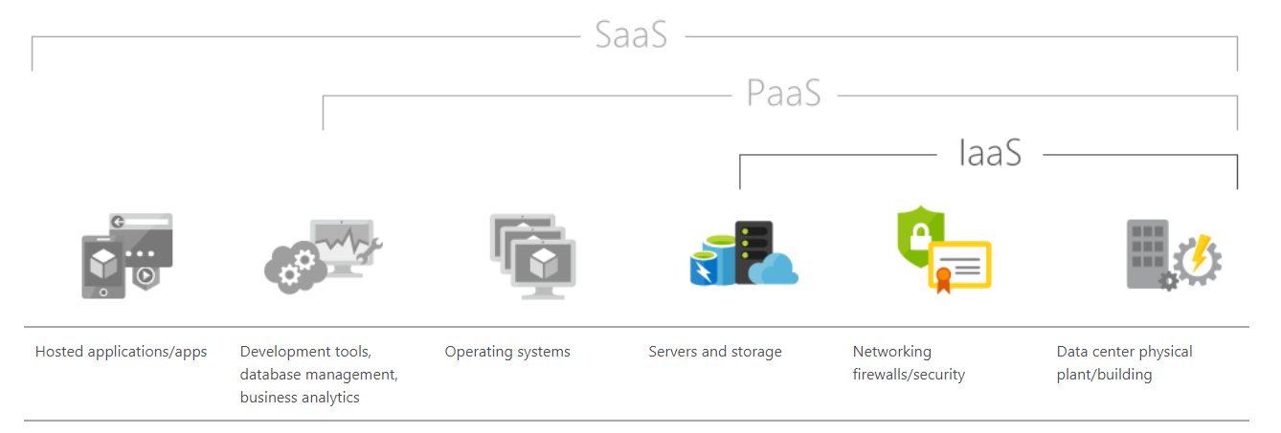

**Your company plans to migrate all its data and resources to Azure.**

**The company's migration plan states that only platform as a service (PaaS) solutions must be used in Azure.**

**You need to deploy an Azure environment that supports the planned migration.**

**Solution: You create an Azure App Service and Azure virtual machines that have Microsoft SQL Server installed.**

**Does this meet the goal?**

Ans - No

**Choose all that apply.**

### To achieve a hybrid cloud model, a company must always migrate from a private cloud model.

### A company can extend the capacity of its internal network by using the public cloud.

### In a public cloud model, only guest users at your company can access the resources in the cloud.

**Which cloud deployment solution is used for Azure virtual machines and Azure SQL databases?**

**Choose all that apply.**

### Ans - Azure virtual machines: Infrastructure as a service (IaaS).

### Azure SQL databases: Platform as a service (PaaS).

**You plan to migrate several servers from an on-premises network to Azure.**

**You need to identify the primary benefit of using a public cloud service for the servers.**

**What should you identify?**

### Ans - The public cloud is a shared entity whereby multiple corporations each use a portion of the resources in the cloud.

**You have 1,000 virtual machines hosted on the Hyper-V hosts in a data center.**

**You plan to migrate all the virtual machines to an Azure pay-as-you-go subscription.**

**You need to identify which expenditure model to use for the planned Azure solution.**

**Which expenditure model should you identify?**

Ans – Operational

**Match the Azure Cloud Services benefit to the correct description.**

**Choose all that apply.**

Ans –

### Disaster recovery: A cloud service that remains available after it occurs.

### Disaster recovery: A cloud service that can be recovered after it occurs.

### Disaster recovery: A cloud service that performs quickly when it increases.

### 

### Disaster recovery: A cloud service that can be accessed quickly to the Internet.

### Fault tolerance: A cloud service that remains available after it occurs.

### Fault tolerance: A cloud service that can be recovered after it occurs.

### Fault tolerance: A cloud service that performs quickly when it increases.

### Fault tolerance: A cloud service that can be accessed quickly to the Internet.

### Low latency: A cloud service that remains available after it occurs.

### Low latency: A cloud service that can be recovered after it occurs.

### Low latency: A cloud service that performs quickly when it increases.

### Low latency: A cloud service that can be accessed quickly to the Internet.

### Dynamic scalability: A cloud service that remains available after it occurs.

### 

### Dynamic scalability: A cloud service that can be recovered after it occurs.

### Dynamic scalability: A cloud service that performs quickly when it increases.

### Dynamic scalability: A cloud service that can be accessed quickly to the Internet

**Choose all that apply.**

Ans-

### Azure resources can only access other resources in the same resource group.

### If you delete a resource group, all the resources in the resource group will be deleted.

### A resource group can contain resources from multiple Azure regions.

**Your company has an on-premises network that contains multiple servers.**

**The company plans to reduce the following administrative responsibilities of network administrators:**

**\* Backing up application data**

**\* Replacing failed server hardware**

**\* Managing physical server security**

**\* Updating server operating systems**

**\* Managing permissions to shared documents**

**The company plans to migrate several servers to Azure virtual machines.**

**You need to identify which administrative responsibilities will be reduced after the planned migration.**

**Which two responsibilities should you identify? Each correct answer presents a complete solution.**

Ans –

### Replacing failed server hardware.

### Backing up application data.

### Managing physical server security.

### Updating server operating systems.

### Managing permissions to shared documents.

Q)

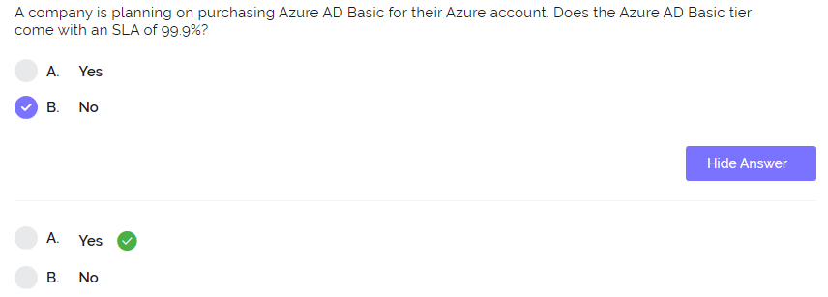

Explanation :

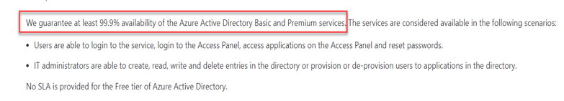

Q)

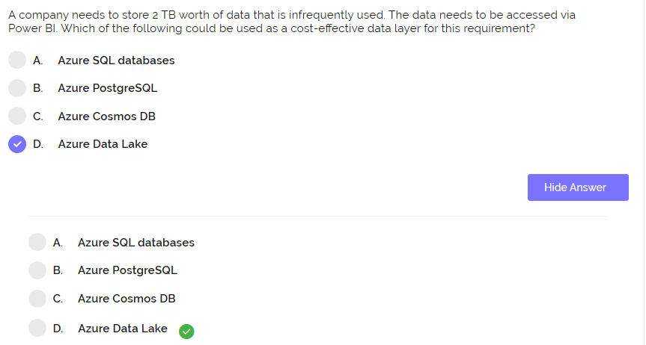

Q)

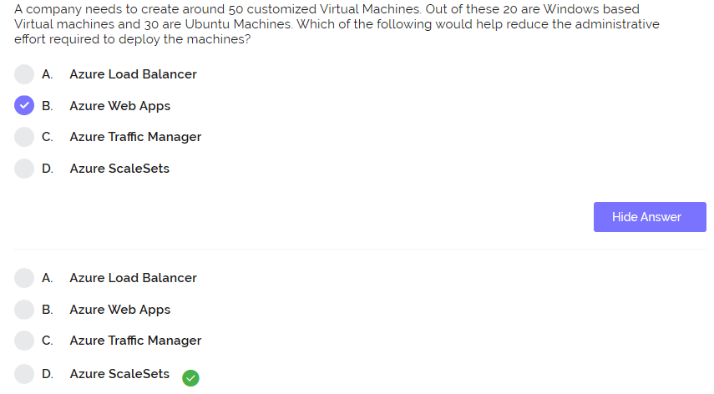

Q)

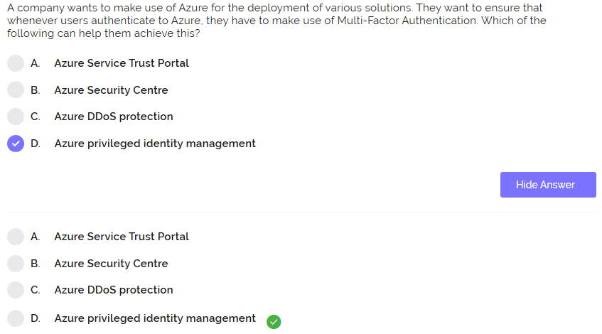

Explanation :

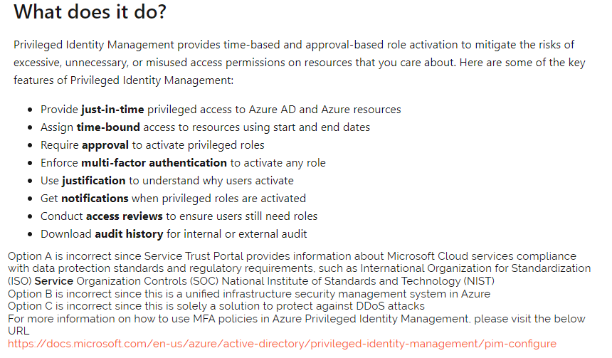

Q)

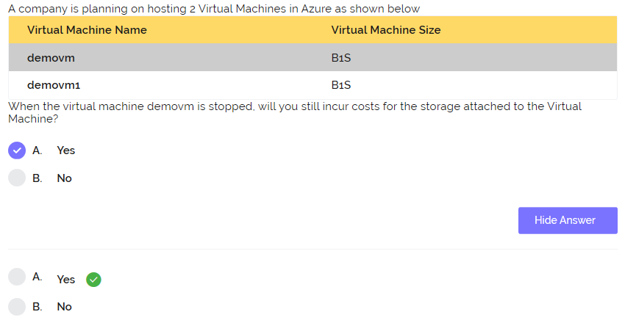

Q)

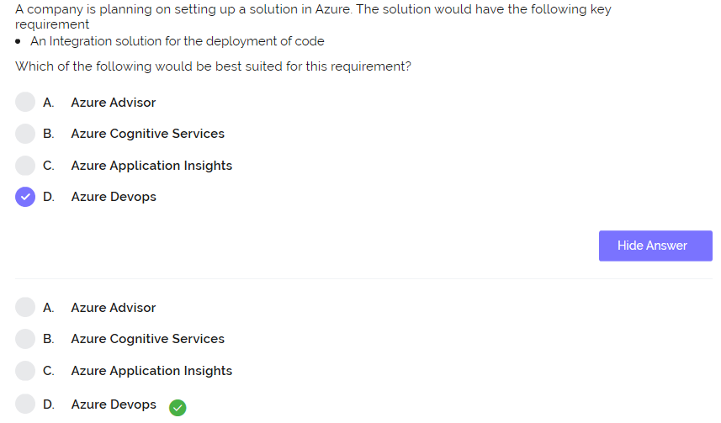

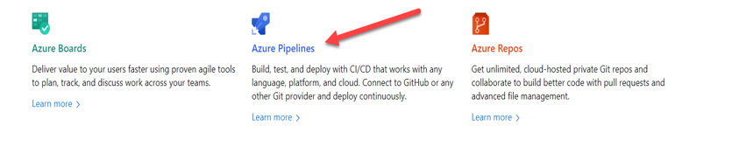

Q)

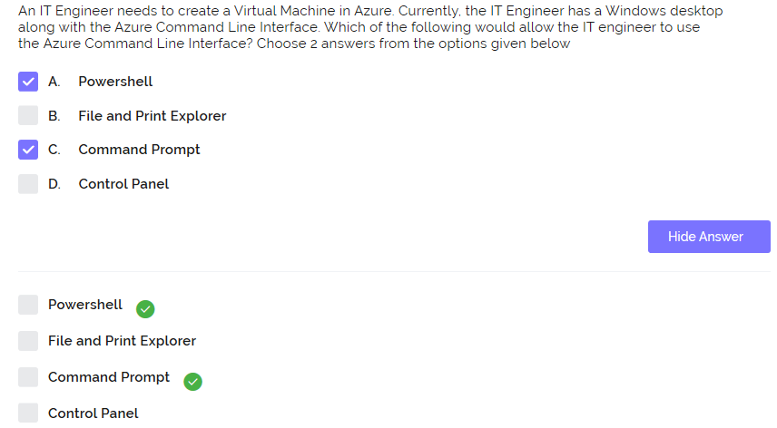

Q)

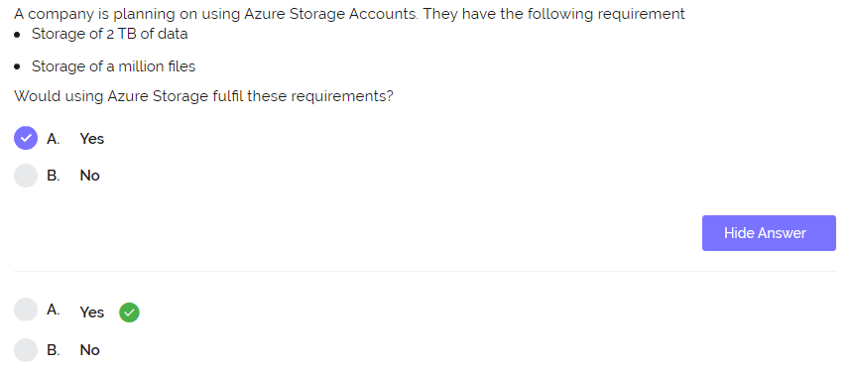

Explanation :

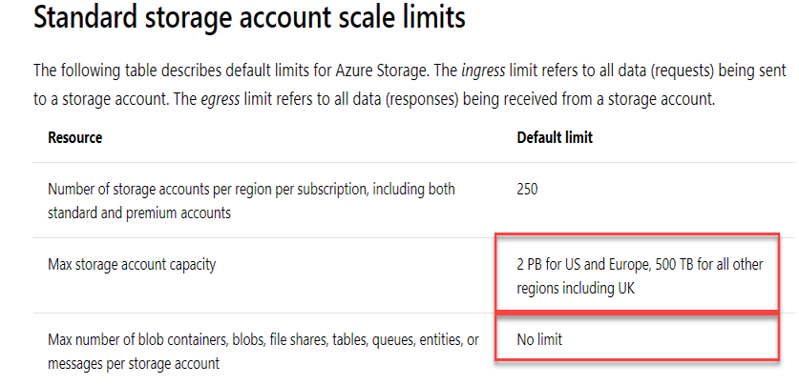

Q)

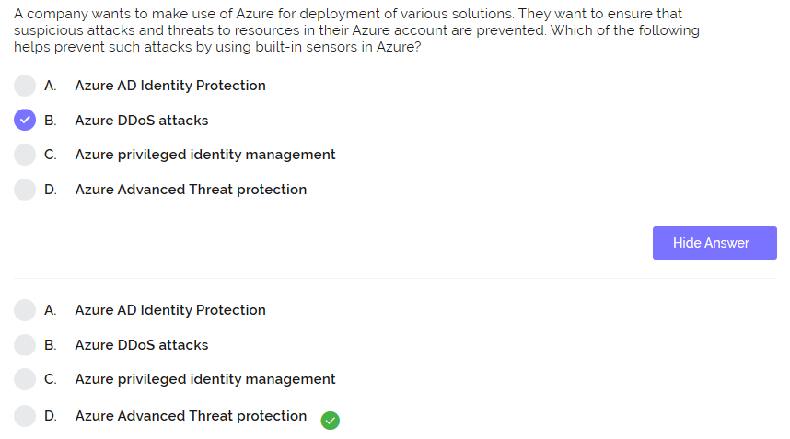

Explanation :

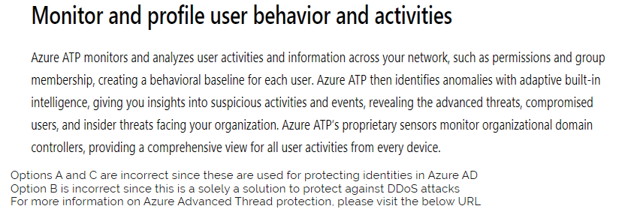

Q)

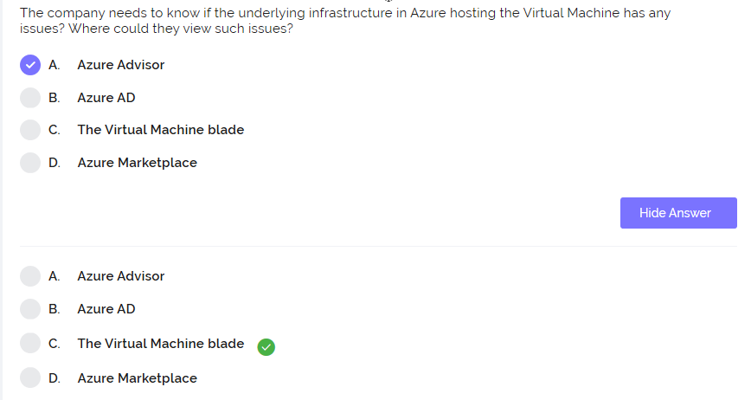

In the resource health tab.

Q)

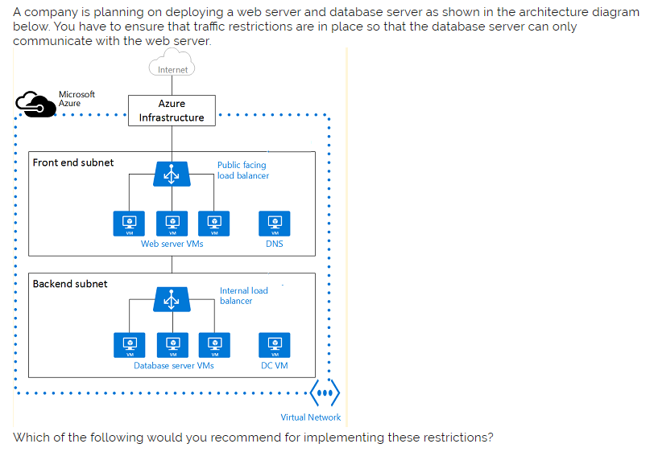

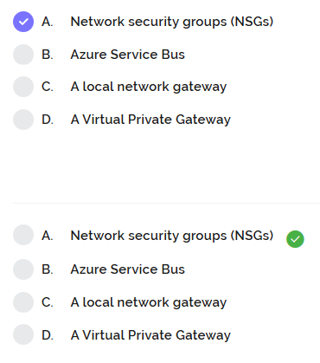

Q)

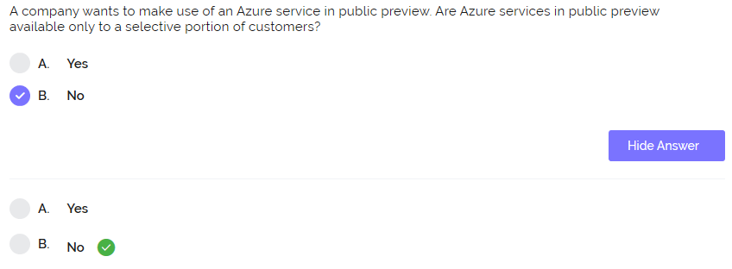

Q)

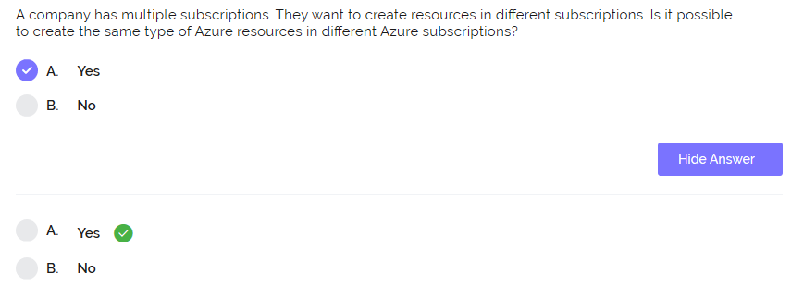

You have an Azure Active Directory (Azure AD) tenant.

All administrators must enter a verification code to access the Azure portal.

You need to ensure that the administrators can access the Azure portal only from your on-premises network.

What should you configure?

Ans - The multi-factor authentication service settings.

You have two Azure Active Directory (Azure AD) tenants named contoso.com and fabrikam.com.

You have a Microsoft account that you use to sign in to both tenants.

You need to configure the default sign-in tenant for the Azure portal.

What should you do?

Ans - From Azure Cloud Shell, run Set-AzureRmContext.

**For each of the following statements, select Yes if the statement is true. Otherwise, select No.**

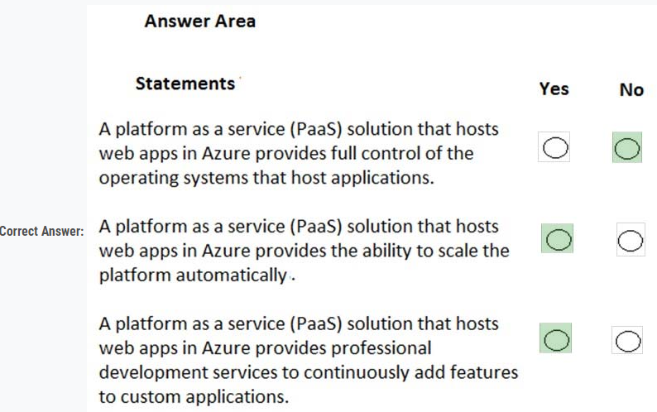

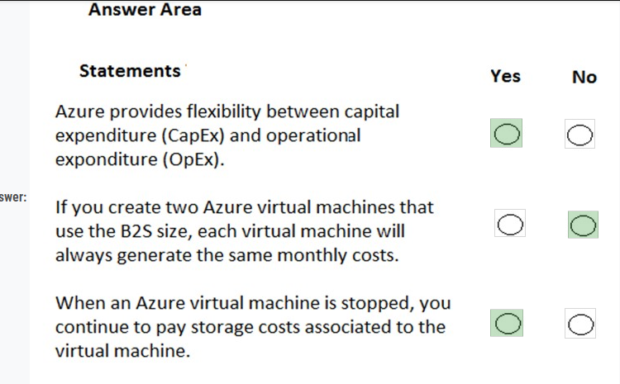

**When you are implementing a software as a service (SaaS) solution, you are responsible for configuring high availability.  
Instructions: Review the underlined text. If it makes the statement correct, select "No change is needed". If the statement is incorrect, select the answer choice that makes the statement correct.**

Ans – No, it’s configuring the SaaS solution

**You have an on-premises network that contains several servers.  
You plan to migrate all the servers to Azure.  
You need to recommend a solution to ensure that some of the servers are available if a single Azure data center goes offline for an extended period.  
What should you include in the recommendation?**

Ans - fault tolerance

**This question requires that you evaluate the underlined text to determine if it is correct.  
An organization that hosts its infrastructure in a private cloud can decommission its data center.**

Ans -  in the public cloud

**What are two characteristics of the public cloud? Each correct answer presents a complete solution.**

Ans - metered pricing, self-service management

**This question requires that you evaluate the underlined text to determine if it is correct.  
When planning to migrate a public website to Azure, you must plan to pay monthly usage costs.**

Ans – No change required

**Your company plans to migrate all its data and resources to Azure.  
The company's migration plan states that only platform as a service (PaaS) solutions must be used in Azure.  
You need to deploy an Azure environment that supports the planned migration.**

**Solution: You create an Azure App Service and Azure SQL databases.  
Does this meet the goal?**

Ans – Yes

**Solution: You create an Azure App Service and Azure virtual machines that have Microsoft SQL Server installed.  
Does this meet the goal?**

Ans – No

**Solution: You create an Azure App Service and Azure Storage accounts.**

Ans- No

**Your company hosts an accounting named App1 that is used by all the customers of the company.  
App1 has low usage during the first three weeks of each month and very high usage during the last week of each month.  
Which benefit of Azure Cloud Services supports cost management for this type of usage pattern?**

Ans - Elasticity

**You plan to migrate a web application to Azure. The web application is accessed by external users.  
You need to recommend a cloud deployment solution to minimize the amount of administrative effort used to manage the web application.  
What should you include in the recommendation?**

Ans – PaaS

**You have an Azure environment. You need to create a new Azure virtual machine from a tablet that runs the Android operating system.  
Solution: You use Bash in Azure Cloud Shell.  
Does this meet the goal ?**

Ans – Yes

You plan to create an Azure virtual machine.  
You need to identify which storage service must be used to store the unmanaged data disks of the virtual machine.  
What should you identify? To answer, select the appropriate service in the answer area.

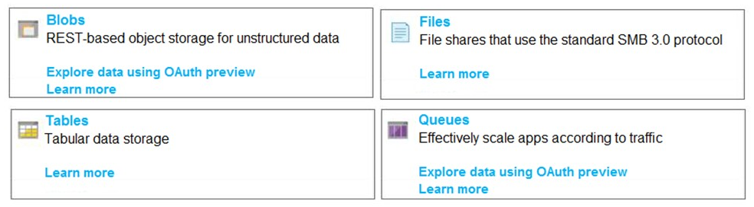

Ans - Blobs

Explanation:  
Azure page blobs are the backbone of the virtual disks platform for Azure IaaS. Both Azure OS and data disks are implemented as virtual disks where data is durably persisted in the Azure Storage platform and then delivered to the virtual machines for maximum performance. Azure Disks are persisted in Hyper-V VHD format and stored as a page blob in Azure Storage.

Your company plans to move several servers to Azure.  
The companyâ€™s compliance policy states that a server named FinServer must be on a separate network segment.  
You are evaluating which Azure services can be used to meet the compliance policy requirements.  
Which Azure solution should you recommend ?

Ans - a virtual network for FinServer and another virtual network for all the other servers.